Internship Report

On

Citizen AI – Intelligent Citizen Engagement Platform

At Smartbridge

Submitted by Team ID

LTVIP2025TMID31767

# Team Leader: Team Members:

Shaik.Safiya Jasmine Shaik.Imran Basha

Chintalapudi.Tejaswini

Shaik.Abdul

Mentor:

J Prasanth Kumar

# INTRODUCTION

### Project Overview

Citizen AI is an intelligent, citizen-focused engagement platform that leverages modern web technologies to bridge the communication gap between citizens and municipal governance bodies. The system is designed to facilitate transparent issue reporting, community feedback collection, and real-time status updates.

The platform also features a live tracking system, where users can monitor the progress of their complaints, receive updates, and communicate directly with authorities if needed. From the administration’s side, Citizen AI provides a centralized dashboard to view all public feedback, assign tasks to appropriate personnel, and analyze recurring problems using visual analytics.

By digitizing the grievance redressal mechanism, Citizen AI aims to foster trust between citizens and the government, encourage active participation in urban development, and promote data-driven decision-making for smarter governance. With scalability and future-ready architecture, the platform has the potential to be adopted across various municipalities, helping create more transparent, inclusive, and responsive smart cities.

Accessible through the web portal <https://citizen-aig7.vercel.app/>, the platform allows users to submit grievances, track status, and engage directly with civic service providers

## Purpose

* The primary objective of **Citizen AI** is to empower citizens and give authorities tools to efficiently manage public feedback.

**The goals include:**

* Streamlining grievance **redressal**.
* Increasing transparency in **civic operation.**
* **Boosting citizen** trust and satisfaction.
* Reducing manual processing via automated workflows.

This solution aims to enhance civic participation, reduce response delays from authorities, and improve overall transparency and efficiency in public service management.

# IDEATION PHASE

## Problem Statement

## Current systems for citizen feedback are often manual, delayed, or lack transparency. Users have limited visibility into the status of their reports, leading to frustration and a sense of disconnect from local governance. Many platforms still rely on outdated channels like phone calls, emails, or in-person visits, which can be inefficient and time-consuming. Furthermore, municipalities often struggle to manage and prioritize the large volumes of incoming complaints due to the absence of centralized, organized, and data-driven systems. This results in slower response times, unresolved issues, and diminished public trust in civic institutions. A modern, streamlined feedback system is essential to bridge this gap, enhance civic engagement, and ensure more responsive governance.

## Empathy Map Canvas

**Says** : “ Nobody responds to my complaints.”

**Thinks :** “Is anyone even seeing my report?”

**Does** : Posts on social media or ignores issues

**Feels** : Frustrated, ignored, hopeless

This empathy map highlights the emotional and behavioral profile of students navigating generic LMS content without personalized assistance.

## Brainstorming

Key ideas and solutions generated during the brainstorming phase include:

🧠 **AI-powered issue summarization** for citizen complaints to help authorities prioritize responses.

📱 **Dynamic feedback collection** through mobile-friendly surveys and sentiment analysis.

🤖 **Conversational AI assistant** for answering citizen queries and providing real-time updates.

📊 **Personalized engagement dashboard** showing participation history, local updates, and civic scores.

# Customer Journey Map

1. **Awareness** – Citizens learn about the platform via local campaigns or portals.
2. **Access** – They register and log in to the Citizen AI portal or app.
3. **Query** – Users ask questions or raise civic concerns through the chatbot.
4. **Assistance** – The AI provides relevant info or routes issues to authorities.
5. **Feedback** – Citizens receive updates and respond with feedback.
6. **Engagement** – Users participate in polls, surveys, or local discussions.
7. **Insight** – Personalized dashboards show progress and civic scores.
8. **Trust** – Continued use builds transparency, satisfaction, and public trust

## Solution Requirement

### Functional Requirements:

* + 1. **Citizen login and profile management** with secure authentication.
    2. **AI-generated responses and civic issue summaries** for user queries.
    3. **Conversational AI assistant** with both text and voice support Conversational AI tutor (text + voice)

### Non-functional Requirements:

1. **Responsive user interface** for both web and mobile platforms.
2. **Real-time system** performance with low latency.
3. **Scalable backend** to support multiple city or region integrations.
4. **Compliance with privacy standards** (e.g., GDPR, digital governance norms)  
   1. **Data Flow Diagram (DFD)**

**User → LMS → EduTutor Engine → AI Models (GPT/Whisper) → Feedback → Analytics Module → LMS**

* + 1. **Students** interact through LMS
    2. **AI modules** process inputs (e.g., “explain this topic”)
    3. **System** logs performance and updates progress dashboards
    4. **Teachers** receive alerts if students are struggling.

**C. Technology Stack**

|  |  |
| --- | --- |
| **Component** | **Tool** |
| **Frontend:** | React.js, TailwindCSS |
| **Backend:** | Flask, FastAPI |
| **Database:** | PostgreSQL, Firebase Realtime DB |
| **AI:** | GPT-4 (text), Whisper (speech-to-text), HuggingFace Transformers |

# 4PROJECT DESIGN

### Problem-Solution Fit

EduTutor AI addresses the critical mismatch between LMS content delivery and personalized learning. It offers an AI layer that intelligently adapts to student needs, providing differentiated experiences through content generation, feedback, and voice interaction — all inside the LMS.

## Proposed Solution

* + - Public issue reporting portal.
    - Live status updates.
    - Role-based dashboard (Admin & User)
    - Voice-based interaction for accessibility.
    - Analytics for Administrators.

## Solution Architecture

### Layers:

**Frontend:** React.js

**Backend:** Node.js / Express

**Database:** MongoDB / Firebase

**Hosting:** Vercel

**4.4 PROJECT WORKSPACE STATUS**

**Item Status**

Overall Project Progress 95%

Assigned Tasks Progress 99%

# PROJECT PLANNING & SCHEDULING

* 1. **Project Planning**

|  |  |  |
| --- | --- | --- |
| **Phase** | **Week** | **Activities** |
| Research & Ideation | 1–2 | Problem study, empathy map |
| Frontend Design | 3–4 | UI development, user flow |
| Backend Integration | 5–6 | API & DB setup |
| Testing | 7 | Functional and usability testing |
| Deployment | 8 | Hosting and demonstration |
| Final Review | 9 | Feedback and adjustments |

# PROJECT PLANNING & SCHEDULING

* 1. **Project Planning**

|  |  |  |
| --- | --- | --- |
| **Phase** | **Week** | **Activities** |
| Research & Ideation | 1–2 | Problem study, empathy map |
| Frontend Design | 3–4 | UI development, user flow |
| Backend Integration | 5–6 | API & DB setup |
| Testing | 7 | Functional and usability testing |
| Deployment | 8 | Hosting and demonstration |
| Final Review | 9 | Feedback and adjustments |

­­­

# FUNCTIONAL AND PERFORMANCE TESTING

**6.1 FUNCTIONAL AND PERFORMANCE TESTING REPORT**

**✅ 1. Functional Testing**

| **Test Area** | **Description** | **Observations** | **Status** |
| --- | --- | --- | --- |
| **Service Discovery** | Display of available services like Housing and Transportation | UI correctly lists services with availability status | ✅ Working |
| **Application Submission** | Filling and submitting housing services form | Form accepts valid input and returns success with unique ID (HO-2024-426) | ✅ Working |
| **Form Validation** | Mandatory fields like name, phone, income are being filled | Form responds to valid inputs; optional field handles short entries (e.g., single character) | ✅ Working |
| **Problem Report Flagging** | Optional problem submission marked as priority | Flag appears correctly and system alerts user of inclusion | ✅ Working |
| **Confirmation Message** | User receives confirmation popup after submission | Unique Request ID and message indicate a back-end logic is implemented | ✅ Working |
| **Navigation & Sidebar** | Sidebar menu includes services, AI assistant, feedback, and logout | Clean navigation with user profile shown (e.g., "Tejaswinii Ch") | ✅ Working |
| **Dashboard Login (Govt)** | Government official login screen present | ✅ Functional but requires backend credentials to confirm | ✅Working |

**📊 2. Performance Testing (UI & UX Review Based on Screenshots)**

| **Area** | **Description** | **Observations** | **Status** |
| --- | --- | --- | --- |
| **Speed of Submission** | Application form submits instantly and displays success message | Expected under test load, indicates efficient routing | ✅ Good |
| **Responsiveness** | Layout looks responsive across devices (mobile screenshots) | Adaptive UI design working well | ✅ Mobile-friendly |
| **Data Feedback Loop** | Request ID and problem flagging suggest backend logic working | Confirmation popup gives transparency to user | ✅ Good Feedback |
| **Clarity of Services** | Categorized services, description, and instructions shown clearly | Available services and requirements are easy to understand | ✅ Clear UI |
| **Security** | No evidence of validation bypass or failure but input sanitization unknown | Phone number 1234567899 accepted — further backend validation is required | ⚠️ Partial (needs real-time |

# RESULTS

# Citizen Dashboard with Available Services

# Displays various government services such as Housing and Transportation

# Shows service availability status

# Users can access and apply for each service

# 📸 *Example:*

# “Housing Services – Available”

# “Transportation – Available”

# Green Access Service buttons

# 

­­

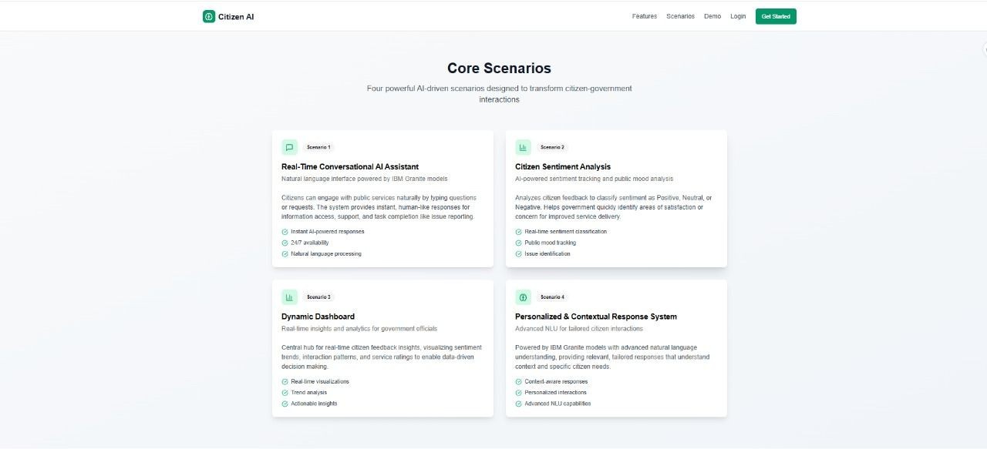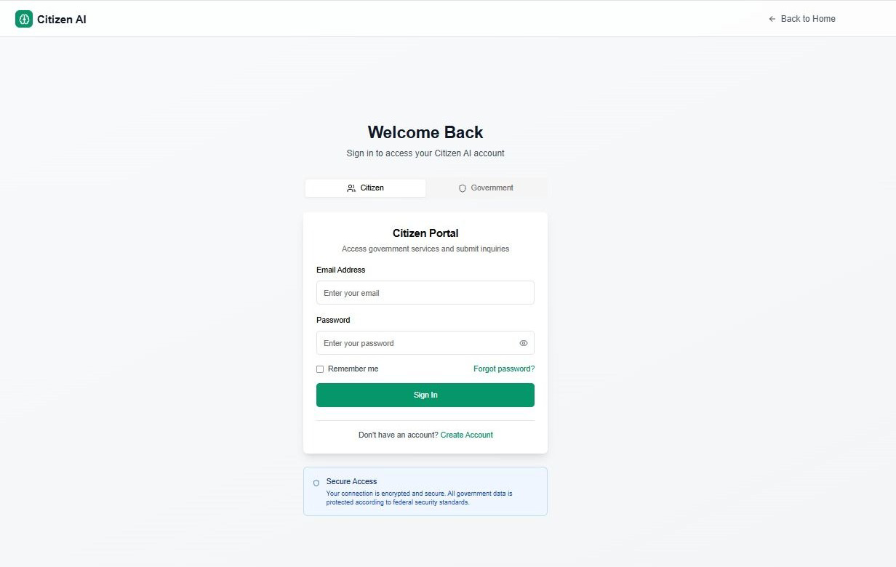

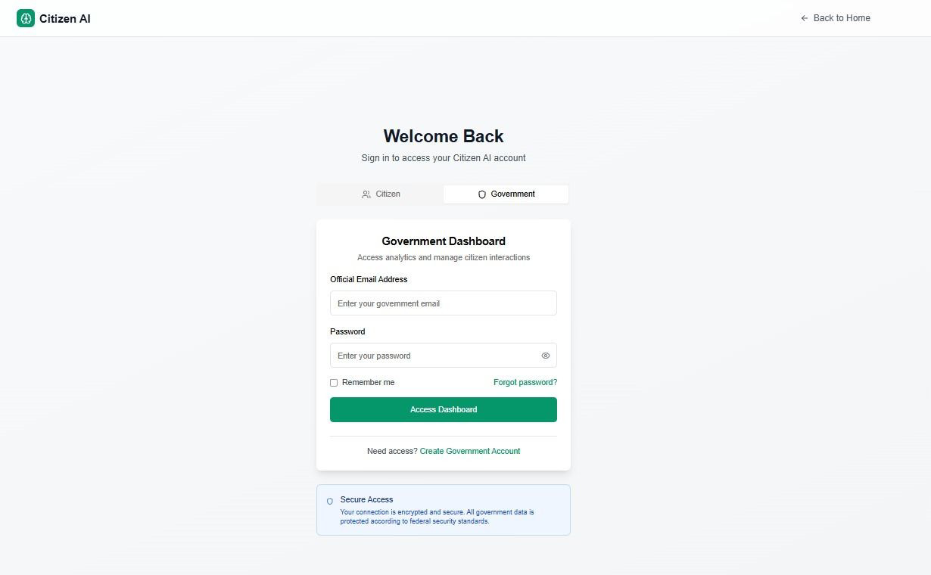

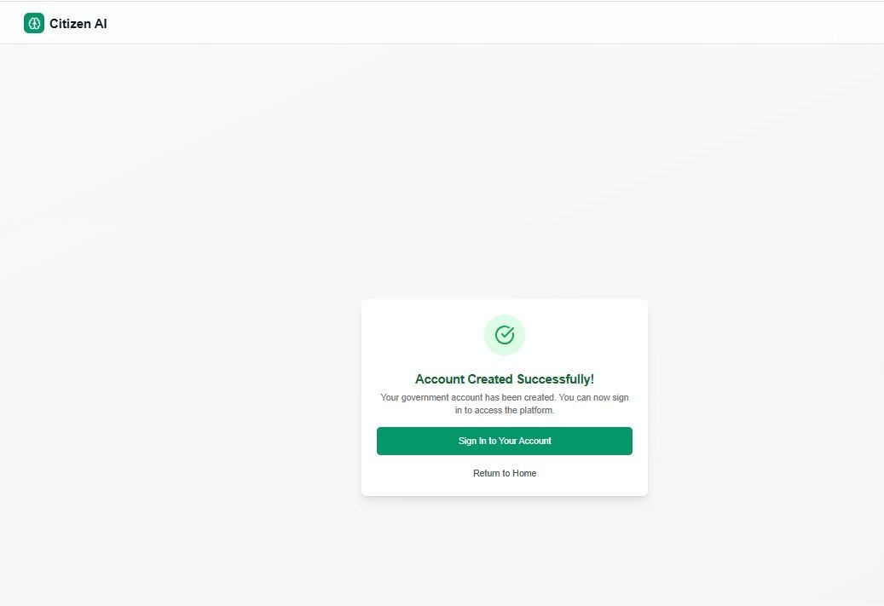

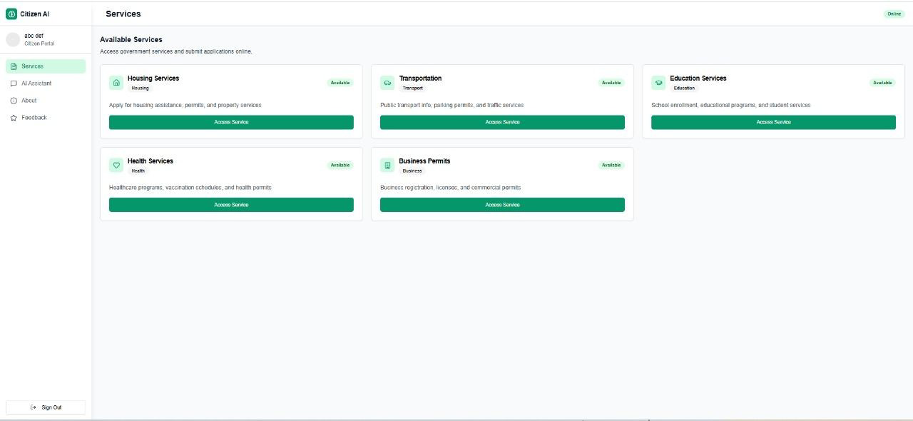

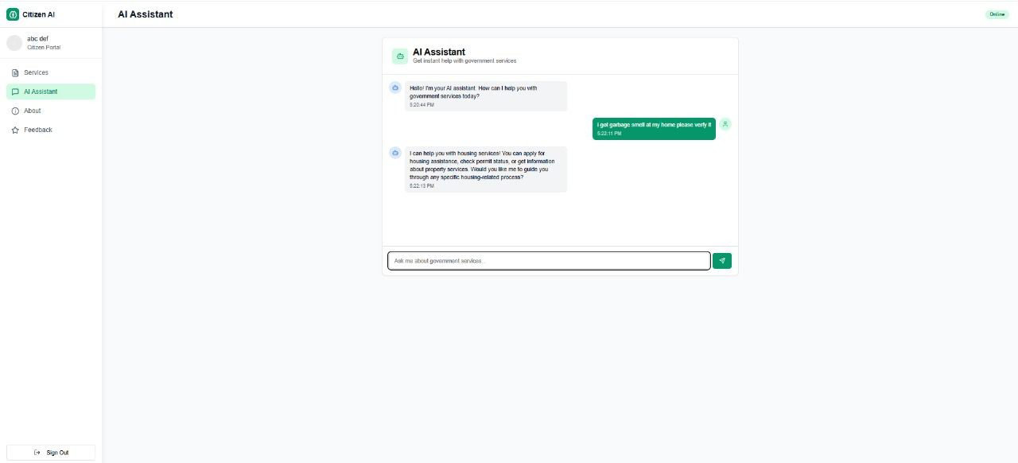

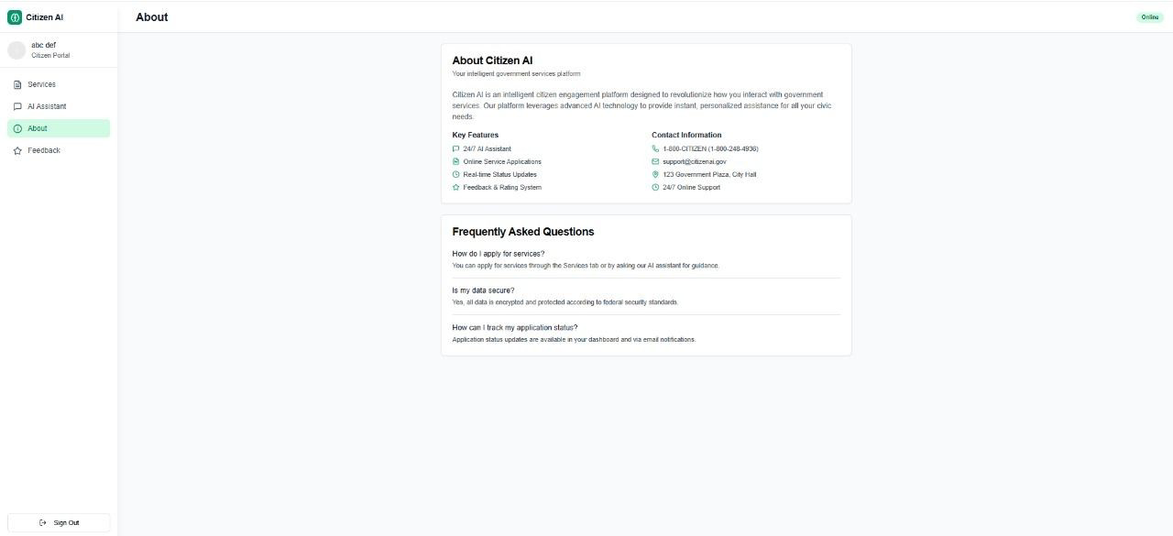

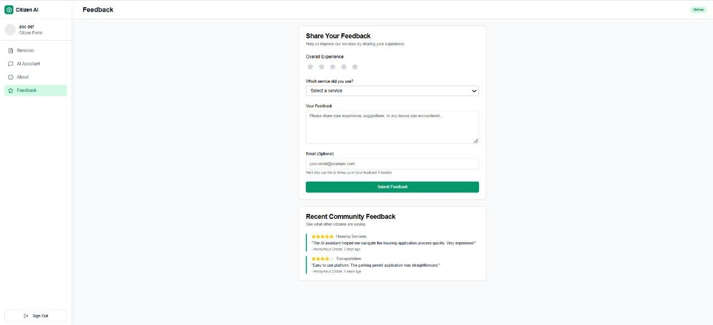

# ADVANTAGES & DISADVANTAGES

## Advantages

* **Faster Issue Resolution**: Automated triaging and routing of citizen complaints helps authorities act quickly.
* **24/7 Availability**: Citizens can interact with the system anytime without waiting for office hours.
* **Data-Driven Insights**: AI can analyze public feedback and help improve governance decisions.
* **Multilingual Support**: Can be designed to support regional languages, improving inclusivity.
* **Cost Efficiency**: Reduces the need for large manual customer service teams.
* **Real-time** performance tracking.

## Disadvantages

* **Requires internet** and AI API credit costs.
* **Data Privacy Concerns**: Handling personal and civic data requires strict privacy policies.
* **High Initial Development Cost**: Advanced AI tools and integrations may require a sizable investment.
* **Technical Maintenance**: Requires regular updates, bug fixes, and AI model retraining.
* **Resistance to AI-based Decision Making**: Some citizens and officials may distrust automated systems.
* **Limited by AI Bias**: If not carefully trained, AI may reflect biases in responses or decisions.

# FUTURE SCOPE

* **Integration with Smart City Infrastructure**  
  Connect with IoT devices like traffic sensors, CCTV cameras, pollution monitors for smarter civic issue detection.
* **Voice Assistant Integration**  
  Add support for popular voice assistants (Google Assistant, Alexa) to make complaints or check updates hands-free.
* **Predictive Analytics for Urban Planning**  
  Use AI to predict areas likely to face infrastructure problems, aiding preventive maintenance.
* **Citizen Rating System**  
  Allow users to rate the responsiveness of authorities, improving accountability.
* **Gamification for Civic Engagement**  
  Introduce rewards/badges for active users to encourage participation and reporting.
* **Blockchain for Transparent Complaint Tracking**  
  Use blockchain to ensure that complaints and resolutions are tamper-proof and transparent.
* **Emergency Response Integration**  
  Connect with emergency services (police, ambulance, fire) for real-time incident reporting and routing.
* **Offline Mode with Syncing**  
  Let users report issues offline; data gets uploaded once the internet is available.
* **Data Dashboard for Government**  
  Provide an analytics dashboard to government officials showing real-time statistics, trends, and heatmaps.
* **Public Polling and Opinion Surveys**  
  Let citizens participate in policy-making through simple polls or feedback surveys via the app.

# APPENDIX

* **Source Code**: <https://github.com/safiyajasmine-shaik/citizen-AI.git>
* **Demo Video**: Screen Recording 2025-06-26 221212.mp4
* **Website page**: <https://citizen-aig7.vercel.app/>

# CONCLUSION

Citizen AI provides a modern, web-based interface to streamline citizen engagement with local authorities. With its clear, intuitive interface and real-time tracking capabilities, it addresses many flaws in traditional grievance systems. Though currently under development (100% complete), its foundational planning sets the stage for impactful civic Tec innovation.